**DAILY ONLINE ACTIVITIES SUMMARY**

|  |  |  |  |  |  |  |  |  |
| --- | --- | --- | --- | --- | --- | --- | --- | --- |
| **Date:** | **03/06/2020** | | | | | **Name:** | **Sathvik R Shetty** | |
| **Sem & Sec** | **6th /B** | | | | | **USN:** | **4AL17CS089** | |
| **Online Test Summary** | | | | | | | | |
| **Subject** | | **PAP assignment test** | | | | | | |
| **Max. Marks** | | **20** | | **Score** | | | **18** | |
| **Certification Course Summary** | | | | | | | | |
| **Course** | **Web Development** | | | | | | | |
| **Certificate Provider** | | | **Shaw Academy** | | **Duration** | | | **4weeks** |
| **Coding Challenges** | | | | | | | | |
| **Problem Statement:**   1. Problem statement:   Take a list of length 3 containing integers, find out which is larger, first or last one and set all the elements in the list to be that value. Print the updated list.   1. Python program to print prime numbers in the given range. | | | | | | | | |
| **Status: Completed** | | | | | | | | |
| **Uploaded the report in GitHub** | | | | | **Yes** | | | |
| **If yes Repository name** | | | | | <https://github.com/sathvikshetty22/Online-Coding> | | | |
| **Uploaded the report in slack** | | | | | **Yes** | | | |

**Online Test Details**

PAP assignment test Details:

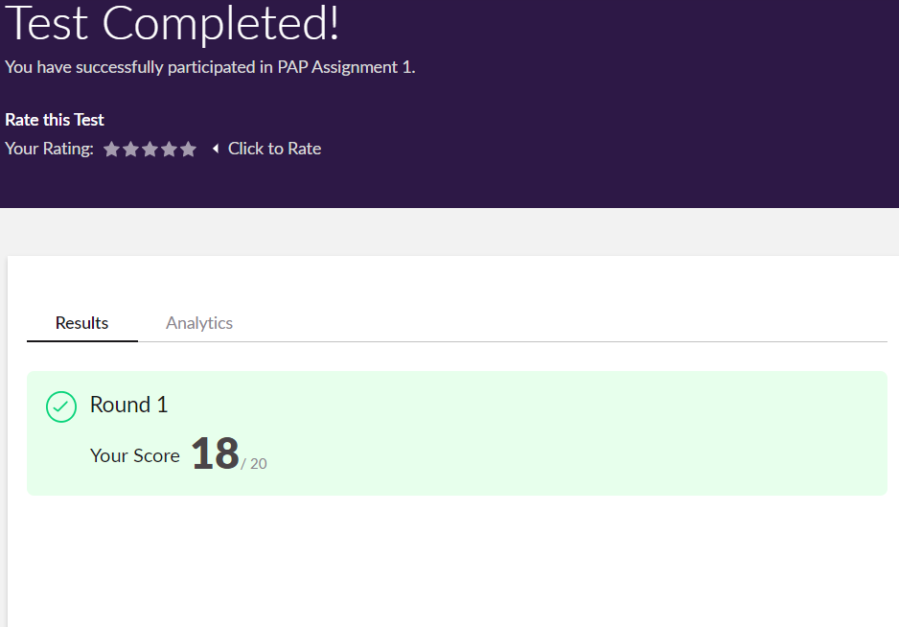

**Online Certification Details**

**Lesson**

* The Web Development Full stack
* 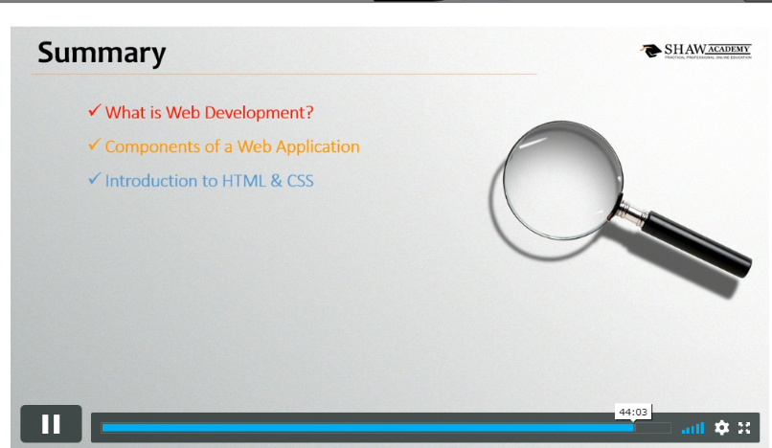Creating Web pages

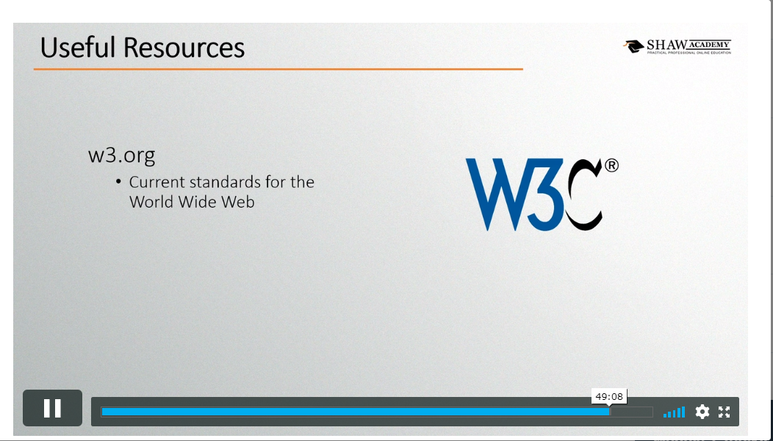**Coding Challenge Details**

1. Problem statement:

Take a list of length 3 containing integers, find out which is larger, first or last one and set all the elements in the list to be that value. Print the updated list.

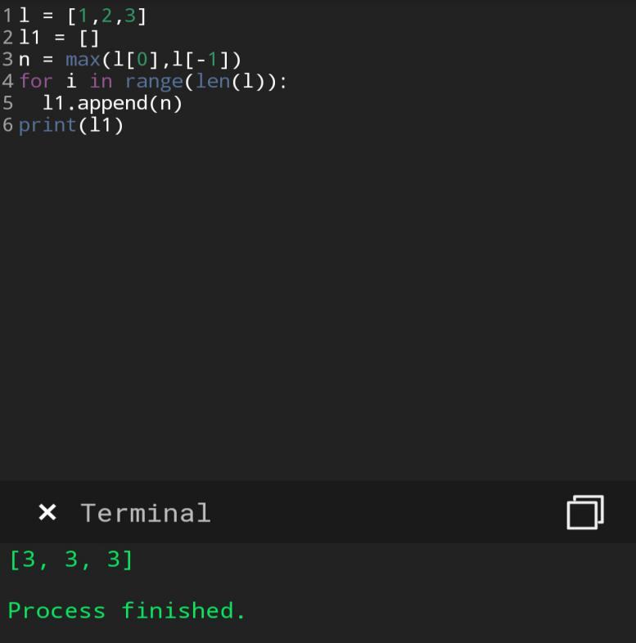

1. Python program to print prime numbers in the given range.

